CREATE TABLE ebookshop (

book_id INT AUTO_INCREMENT PRIMARY KEY,

book_title VARCHAR(255),

book_author VARCHAR(255),

book_price DECIMAL(10, 2),

quantity INT

);

INSERT INTO ebookshop (book_title, book_author, book_price, quantity) VALUES

('Effective Java', 'Joshua Bloch', 45.00, 10),

('Clean Code', 'Robert C. Martin', 41.50, 15),

('Thinking in Java', 'Bruce Eckel', 37.95, 5);

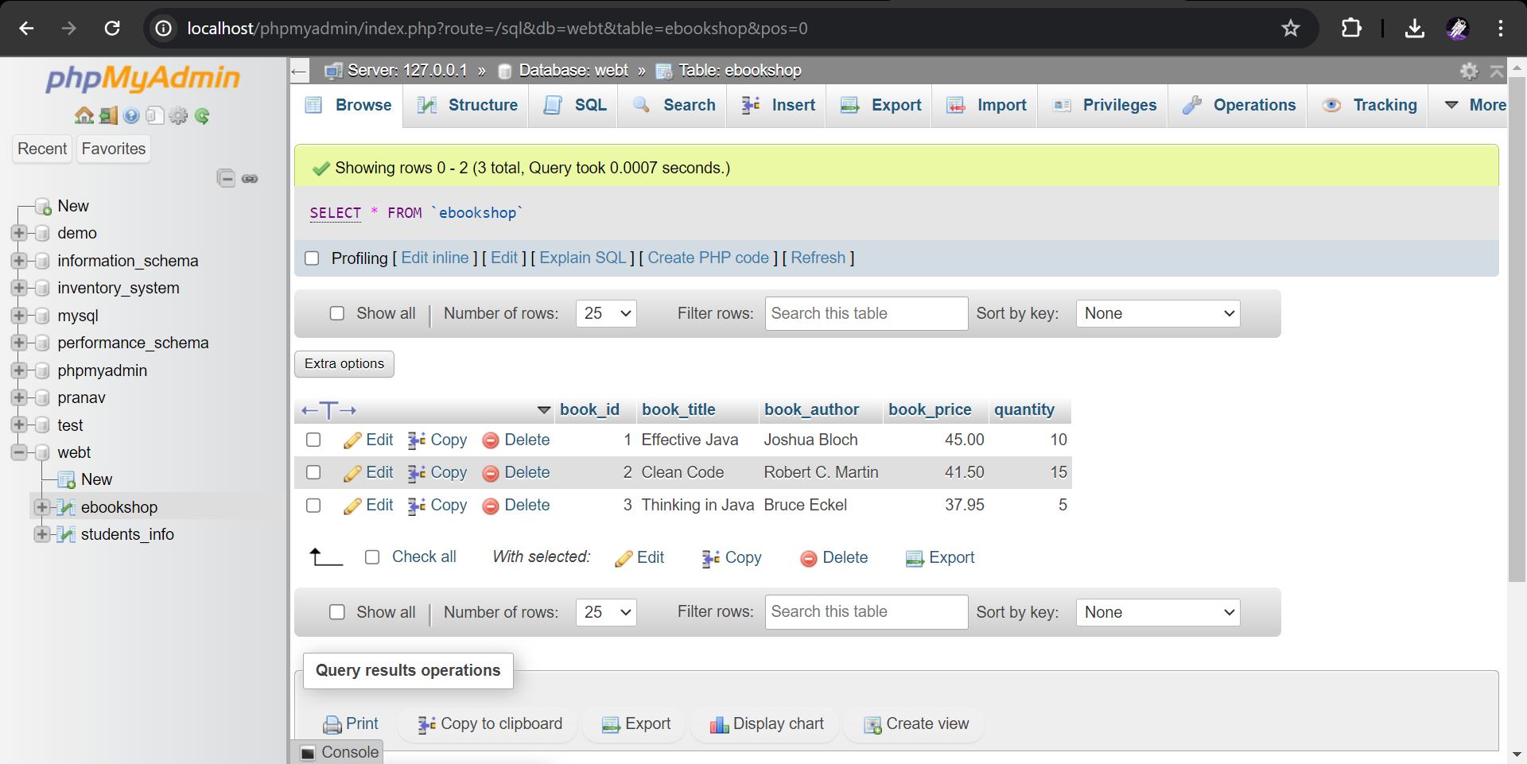

**EbookShopServlet.java**

import java.io.IOException;

import java.io.PrintWriter;

import java.sql.*;

import javax.servlet.*;

import javax.servlet.http.*;

public class EbookShopServlet extends HttpServlet {

public void doGet(HttpServletRequest request, HttpServletResponse response) throws ServletException, IOException {

response.setContentType("text/html");

PrintWriter out = response.getWriter();

Connection conn = null;

Statement stmt = null;

ResultSet rs = null;

try {

Class.forName("com.mysql.cj.jdbc.Driver");

conn = DriverManager.getConnection(

"jdbc:mysql://localhost:3306/webt", "root", "");

stmt = conn.createStatement();

String sqlStr = "SELECT * FROM ebookshop";

rs = stmt.executeQuery(sqlStr);

out.println("<html><body>");

out.println("<h2>Book List</h2>");

out.println("<ul>");

while (rs.next()) {

out.println("<li>" + rs.getString("book_title") + ", " + rs.getString("book_author") + ", $" + rs.getDouble("book_price") + ", Qty: " + rs.getInt("quantity") + "</li>");

}

out.println("</ul>");

out.println("</body></html>");

} catch (Exception e) {

e.printStackTrace();

} finally {

try { rs.close(); } catch (Exception e) { /* ignored */ }

try { stmt.close(); } catch (Exception e) { /* ignored */ }

try { conn.close(); } catch (Exception e) { /* ignored */ }

}

}

}

**Web.xml**

<web-app xmlns="http://xmlns.jcp.org/xml/ns/javaee"

xmlns:xsi="http://www.w3.org/2001/XMLSchema-instance"

xsi:schemaLocation="http://xmlns.jcp.org/xml/ns/javaee http://xmlns.jcp.org/xml/ns/javaee/web-app_3_1.xsd"

version="3.1">

<servlet>

<servlet-name>EbookShopServlet</servlet-name>

<servlet-class>EbookShopServlet</servlet-class>

</servlet>

<servlet-mapping>

<servlet-name>EbookShopServlet</servlet-name>

<url-pattern>/viewBooks</url-pattern>

</servlet-mapping>

</web-app>

